HYDROELECTRICITY: It is an established power generation technology. Hydroelectricity is produced when moving water rotates a turbine shaft; this movement is converted to electricity with an electrical generator. It is energy produced from flowing water.
WORKING OF HYDROPOWER PLANT:
There is dam for collecting water and gate for opening and water from the reservoir (head race) where water move to the tail race means from upper level to lower level. In tail race there is turbine. Surge tank is also present which help in increasing the life of penstock because when water stop moving to the tail race then water will create backpressure in the penstock and water gets collected in surge tank thus not affecting penstock. With the help of penstock water travel from head race to tail race where with the help of nozzle that increases the velocity of water enter in the tail race and strike to the turbine, after striking turbine blades will start rotating, as gear box is connected to the turbine the gear box will rotate and this gear connected further to the generator start producing electricity.
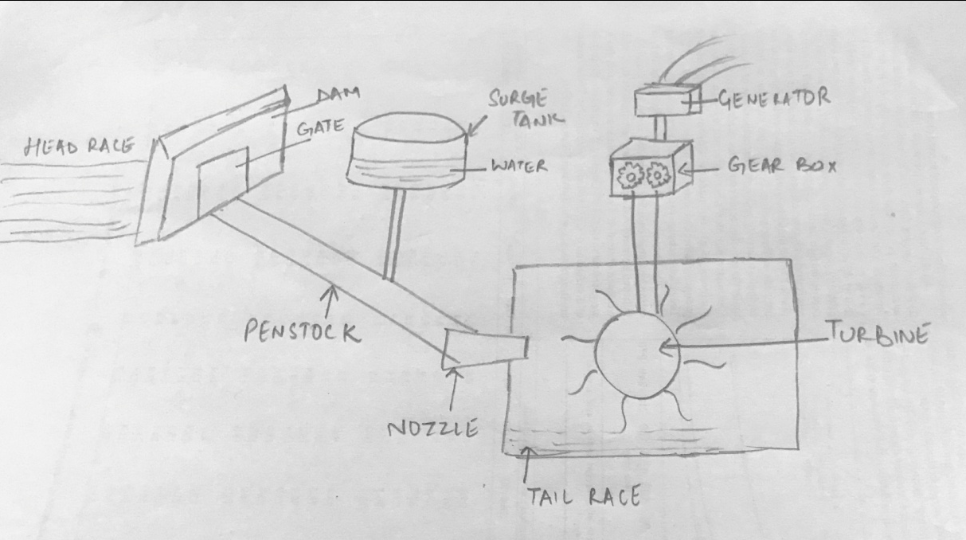

ADVANTAGES:
- Hydroelectricity is a renewable energy source. Hydroelectricity uses the energy of running water to produce electricity.
- Hydroelectricity promotes guaranteed energy and price stability. River water is a domestic resource which, unlike fuel or natural gas, is not subject to market fluctuations.
- Hydroelectricity helps fight climate changes. The hydroelectric life cycle produces very small amounts of greenhouse gases.
- The power plants don’t release pollutants into the air, and hydroelectric developments don’t generate toxic by-products.
- Highly skilled engineers are required only at the time of construction. But later on, only a few experienced people will be required.
DISADVANTAGES:
- Hydropower is non-polluting, but does have environmental impacts. Hydropower facilities can affect land use, homes, and natural habitats in the dam area. Reservoirs may cover people’s homes, important natural areas and agricultural land.
- Building a dam and reservoir to support hydroelectric power takes a lot of money, time, and construction.
- Hydroelectric power plants can cause a loss or modification of fish habitat, and lead to the entrapment of fish and the restriction of their passages.
- In some cases, hydroelectricity can cause changes in reservoir and stream water quality. Operating a hydroelectric power plant may alter the water temperature and the river’s flow. These changes may harm native plants and animals in the river and on land.
- Hydropower plants can be impacted by droughts. When water is not available, the hydropower plants can’t produce electricity.

Pumped hydroelectric energy storage (PHES): Pumped storage is a method of keeping water in reserve for peak period power demands by pumping water that has already flowed through the turbines back up a storage pool above the power plant at a time when customer demand for energy is low, such as during the middle of the night. The water is then allowed to flow back through the turbine-generators at times when demand is high and a heavy load is placed on the system. The reservoir acts much like a battery, storing power in the form of water when demands are low and producing maximum power during daily and seasonal peak periods. An advantage of pumped storage is that hydroelectric generating units are able to start up quickly and make rapid adjustments in output. They operate efficiently when used for one hour or several hours.
